Pizza Dashboard SQL Queries

KPIs

1. Total revenue  
   select round(sum(total_price),2) as total_revenue

from pizza_sales;  
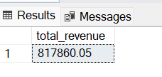

1. Average Order value  
   select round((sum(total_price)/count(distinct order_id)),2) as total_order_value

from pizza_sales;  
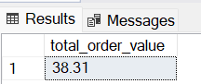

1. Total Pizzas sold  
   select sum(quantity) as total_pizza_sold from pizza_sales;  
   
2. Total orders  
   select count(distinct order_id) as total_orders from pizza_sales;  
   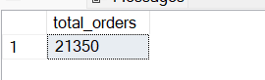

Total Average Pizza Per order

select cast(

(cast(sum(quantity) as decimal(10,2))) /

(cast(count(distinct order_id) as decimal (10,2))) as decimal(10,2))

as total_average_order from pizza_sales;

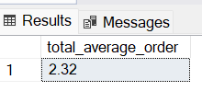

Chart  
1. Week day Trend

select datename(DW,order_date) as day, count(distinct order_id)

from pizza_sales

group by datename(DW,order_date);

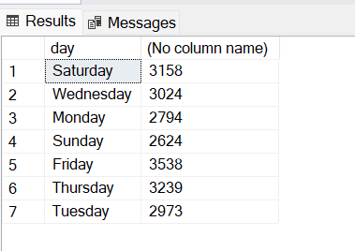

2.Monthly order trend   
select datename(month,order_date) as month, count(distinct order_id) as total_orders

from pizza_sales

group by datename(month,order_date), month(order_date)

order by month(order_date);  
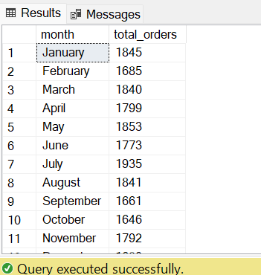

3. Sales revenue by percentage for each category

select pizza_category, sum(total_price) as revenue, sum(total_price) *100

/(select sum(total_price) from pizza_sales) as revenue_percentage

from pizza_sales

group by pizza_category;  
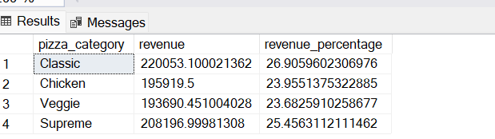

3. Sales revenue by percentage for pizza size

select pizza_size, sum(total_price) as revenue, sum(total_price) *100

/(select sum(total_price) from pizza_sales) as revenue_percentage

from pizza_sales

group by pizza_size;

1. Top 5 selling pizza

SELECT top 5 pizza_name, SUM(total_price) AS revenue

FROM pizza_sales

GROUP BY pizza_name

ORDER BY revenue DESC

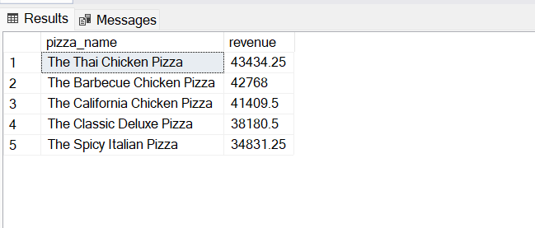

1. Lowest selling pizza

SELECT top 5 pizza_name, SUM(total_price) AS revenue

FROM pizza_sales

GROUP BY pizza_name

ORDER BY revenue   
